Sales and Inventory Management System for A and K Motorcycle Parts and Accessories

A Capstone Project
Presented to the Faculty of the College of Information in Communications Technology Iloilo State University of Fisheries Science and Technology Dingle Campus, Dingle, Iloilo

In Partial Fulfillment of the Requirements for the Degree Bachelor of Science in Information Technology

By:
COBRADOR, JEROLLE
DA-ANOY, CHARLES H.
LADOING, SEAN ANDREI
PEREZ CHUQUEL P.
VILLAFUERTE RON JOFHIL P.

April 2026

Chapter I

INTRODUCTION

Background of the Study
Efficient sales and inventory management is essential for businesses, especially in retail establishments such as motorcycle parts shops, where accurate tracking of products and transactions directly affects profitability and customer satisfaction. Sales and inventory systems help businesses monitor stock levels, record transactions, and generate reports that support decision-making. However, many small and medium enterprises (SMEs) in the Philippines still rely on manual processes such as handwritten records, logbooks, and spreadsheets. These traditional methods are prone to human error, data loss, and inefficiency, resulting in inaccurate inventory counts and delayed operations.
A and K Motorcycle Parts Shop operates across four branches located in Brgy Moroboro Dingle, Ilo-ilo, Brgy. Poblacion Muyco St. Dingle, Ilo-ilo, Brgy. San Matias Dingle, Ilo-ilo, and Bularan St. Banate, Iloilo. experiences increasing challenges in managing sales and inventory using manual methods. These challenges include difficulty in tracking stock across multiple locations, monitoring fast-moving and slow-moving items, accurately recording daily sales transactions, and generating timely consolidated reports. As the business expands, these issues become more complex, leading to potential losses, overstocking, stock shortages, and reduced customer satisfaction.
Several studies emphasize the importance of adopting automated systems. Information systems improve operational efficiency by automating routine processes (Laudon & Laudon, 2020). Similarly, inventory systems help maintain optimal stock levels and improve overall efficiency (O’Brien & Marakas, 2019).Furthermore, integrated systems provide real-time data for better decision-making. (Turban et al., 2021).
To address these challenges, this study proposes the development of a web-based online Sales and Inventory Management System for A and K Motorcycle Parts Shop with four branches. The system is accessible through a web browser on both mobile devices and personal computers. It centralizes sales and inventory data across all branches, automates transactions, monitors stock in real time, and generates accurate reports. The system provides a unified platform where authorized users from different branches can manage data efficiently, ensuring consistency, accuracy, and improved business operations.

Objectives of the Study
This study aims to develop a centralize web-based Sales and Inventory Management System for A and K Motorcycle Parts and accessories with four branches.
Specifically, it aims to:
• Develop a centralize system that integrates sales and inventory data from all four branches.
• Design role-based access for administrators and staff across branches.
• Enable accurate recording of daily sales transactions per branch.
• Implement real-time inventory tracking across multiple locations.
• Generate consolidated and branch-specific reports.
• Evaluate the system based on ISO 25010 standards which includes: Functional Stability, Performance Efficiency, Compatibility, Usability, Reliability, Security, Maintainability, and Portability.

Conceptual Framework
The conceptual framework illustrates how the system operates using the Input-Process-Output (IPO) model.

Output
Sales and Inventory Management System

Process
• User Registration
• Authenticate user
• Manage Product, Inventory, Sales
• Generate report

INPUT
1.User Registration Data
2.Username and Password
3.Product Data
4.Inventory Data
5.Sales Data

Feedback

Figure 1: Conceptual Framework of the Study

This study focuses on the development of a Sales and Inventory Management System for A and K Motorcycle Parts and Accessories, a web-based system design to manage and monitor inventory across its four branches. The system aims to centralize product and stock data, addressing the lack of an organized and efficient method for tracking inventory levels and stock movement between branches. It is design to improve accuracy, accessibility, and real-time monitoring of inventory using web and mobile browsers.

The system utilizes product details, branch inventory data, and sales transactions from all four branches as its primary inputs. These data are processed through a web-based system that performs automated stock updating, sales processing, and centralized database management to ensure accuracy and efficiency across all branches. As a result, the system generates outputs such as consolidated reports, branch-specific reports, stock alerts, and analytical insights that support decision-making. In addition, the system incorporates a feedback mechanism that allows users, including administrators and branch staff, to evaluate system outputs, report errors, and suggest improvements. This feedback is used to enhance system performance, improve usability, and ensure that the system continuously meets the operational needs of the four-branch sales and inventory environment.

The system will be develop using web technologies such as HTML, CSS, JavaScript, and PHP or Node.js, with a MySQL database. It will be deploy as a web-base application and will be accessible through desktop and mobile browsers, allowing real-time synchronization of inventory data across all four branches..

Significance of the Study
The development of the Sales and Inventory Management System for A and K Motorcycle Parts and Accessories will provide a centralize and efficient solution for managing sales and inventory operations across its four branches. The system will streamline business processes, improve accuracy, and enhance overall operational performance. Its significance will extend to several stakeholders:
For the Business Owner: The system will provide centralize control and real-time monitoring of all four branches, enabling better decision-making, improve oversight of inventory levels, and accurate tracking of sales performance.
For Employees: The system will simplify daily workflows by automating sales and inventory processes, resulting in faster transactions, reduce manual workload, and minimize errors in recording and reporting.

For Future Researchers: This study will serve as a reference for developing similar multi-branch web-based systems, contributing to further research and innovation in sales and inventory management solutions.

Scope and Limitation
This study focuses on the development of a web-based Sales and Inventory Management System for A and K Motorcycle Parts Shop with four branches. The system centralizes inventory and sales data while allowing branch-specific operations. It is accessible through web browsers on both mobile devices and personal computers.
Limitations:
• The system depends on internet connectivity for real-time access and synchronization
• It is designed specifically for A and K Motorcycle Parts Shop
• Data accuracy relies on proper user input and system usage

Definition of Terms
Administrator – A person who manages or helps to manage the affairs of a business or organization, specifically responsible for the technical management of a system. (Oxford Learner's Dictionary, 2024)
System User – A person who uses a computer system or software, typically requiring specific permissions to access features. (Merriam-Webster, 2024)
User Authentication – The process of proving that a user is who they claim to be, typically through passwords, biometrics, or security tokens. (TechTarget / Computer Desktop Encyclopedia, 2024)
Centralized Database – A database that is located, stored, and maintained in a single location, which is accessible from multiple points. (Gartner Information Technology Glossary, 2024)
In this study, all sales transactions, inventory records, and product information from the four branches are stored in a single centralized database, ensuring unified data management, consistency, and real-time monitoring of stock and sales across the entire system.
Web-Based System – An application or system that is delivered to users from a web server over a network (such as the Internet) and is accessed through a web browser. (PC Magazine Encyclopedia, 2024)
In this study, the Sales and Inventory Management System for A and K Motorcycle Parts and Accessories is developed as a web-based system, allowing users from all four branches to access and manage sales and inventory data through a web browser using internet-connected devices.
Real-Time Data – Data that is delivered and processed immediately after collection; there is no delay in the timeliness of the information provided.(Cambridge Business English Dictionary, 2024)
Dashboard – A visual display of the most important information needed to achieve one or more objectives, consolidated and arranged on a single screen so the information can be monitored at a glance. (Dictionary of Information Science and Technology, 2024)
Inventory Management – The process of ordering, storing, using, and selling a company's inventory, including the management of raw materials, components, and finished products. (Investopedia, 2024)
Branch – A local office or shop that belongs to a large company or organization. (Collins English Dictionary, 2024)
Stock Level – The quantity of a particular product that is available for sale or use at a specific point in time.(Macmillan Dictionary, 2024)
Stock Alert – An automated notification that triggers when inventory levels fall below a predetermined threshold, signaling a need for replenishment.(BusinessDictionary / Shopify Commerce Glossary, 2024)
Product – An article or substance that is manufactured or refined for sale.(Oxford English Dictionary, 2024)
Point of Sale (POS) – The place where a retail transaction is completed; the point at which a customer makes a payment to the merchant in exchange for goods.(Britannica Money, 2024)
Sales Transaction – An agreement between a buyer and a seller to exchange goods, services, or financial instruments for money. (AccountingTools, 2024)
Transaction History – A chronological record of all activities or movements associated with a specific account or system over a period of time. (Law Insider Dictionary, 2024)
User Interface (UI) – refers to the means by which a user interacts with a computer system or application. The system will provide an interface for staff and administrators to manage sales and inventory efficiently. (Merriam-Webster, 2024)

CHAPTER II
REVIEW OF RELATED LITERATURE
According to Zhang, Huang, and Yuan (2021), inventory management plays a critical role in ensuring operational efficiency, particularly in handling spare parts and maintaining optimal stock levels. Their study explains that effective inventory systems help organizations minimize costs, reduce stock shortages, and improve service performance through systematic approaches and analytical models. Moreover, the authors emphasize that poor inventory management can result in overstocking or understocking, which negatively affects both profitability and customer satisfaction.
In relation to the present study, which focuses on the development of a Sales and Inventory Management System for A&K Motorcycle Parts and Accessories, the ideas presented by Zhang, Huang, and Yuan (2021) are highly relevant. The proposed system aims to solve common problems such as inaccurate inventory tracking, manual recording of sales, and inefficiencies in monitoring stock levels. By implementing a computerized system, the business can achieve real-time updates, improved accuracy, and faster transactions. This supports the concept highlighted in the literature that adopting an efficient inventory management system is essential for improving business operations, especially for enterprises dealing with motorcycle parts and accessories.
According to Zhang, Huang, and Yuan (2021), the integration of modern technology in inventory systems enhances accuracy and decision-making processes. The study highlights that digital inventory systems provide timely data, allowing businesses to respond quickly to changes in demand. This reduces delays and improves the overall flow of operations, particularly in industries dealing with high-demand products like spare parts and accessories.
Similarly, the proposed system for A&K Motorcycle Parts and Accessories aims to incorporate digital solutions to improve business processes. By automating sales and inventory tracking, the system can reduce human errors and ensure that all transactions are properly recorded. This will enable the business owner to make better decisions based on accurate and up-to-date information, reflecting the advantages discussed in the study.

According to Zhang, Huang, and Yuan (2021), effective inventory management not only improves internal operations but also enhances customer satisfaction. The authors point out that when businesses maintain accurate inventory records, they are more capable of meeting customer demands promptly. This leads to better service quality and increased customer trust, which are essential for long-term business success.
In connection with this, the development of a Sales and Inventory Management System for A&K Motorcycle Parts and Accessories is expected to improve customer service by ensuring product availability and faster transaction processing. With a reliable system in place, the business can provide accurate information to customers and avoid delays caused by manual processes. This aligns with the findings of Zhang, Huang, and Yuan (2021), which stress the importance of efficient inventory systems in achieving both operational and customer-related benefits.
According to De Silva (2017), a sales and inventory management system is essential for businesses that handle multiple operational activities such as stock control, invoicing, and reporting. The study explains that organizations relying on manual bookkeeping often experience inefficiencies, increased workload, and higher chances of human error. Furthermore, the author highlights that implementing a computerized system can significantly reduce paperwork, improve accuracy, and enhance the overall quality of business processes by providing reliable and timely outputs.
In relation to the present study, which focuses on the development of a Sales and Inventory Management System for A&K Motorcycle Parts and Accessories, the ideas presented by De Silva (2017) are highly relevant. The business currently relies on manual processes that may lead to errors in recording sales and tracking inventory. By developing a computerized system, the study aims to reduce these inefficiencies, improve data accuracy, and streamline daily operations, similar to the improvements emphasized in the literature.
According to De Silva (2017), existing systems in the market may sometimes be too complex for small or medium-sized businesses, making them difficult to implement effectively. The study emphasizes the importance of designing a system that is simple, user-friendly, and tailored to the specific needs of the organization. This ensures that users can easily adopt the system without requiring extensive training while still achieving efficient inventory and sales management.
Similarly, the proposed system for A&K Motorcycle Parts and Accessories aims to provide a user-friendly interface that simplifies business operations. The system is designed to be easy to use while still covering essential functions such as inventory tracking, sales recording, and report generation. This reflects the need identified in the study for systems that are not overly complicated but still effective in managing business processes.
According to De Silva (2017), the integration of security features and proper system evaluation is also important in developing an effective sales and inventory management system. The study highlights that ensuring data security and evaluating the system through user feedback helps maintain system quality and reliability. These factors contribute to better system performance and long-term usability within the organization.
In connection with this, the development of the Sales and Inventory Management System for A&K Motorcycle Parts and Accessories also considers system security and evaluation. The proposed system will include features that protect business data and ensure that only authorized users can access the system. Additionally, the system will be tested and evaluated to ensure its effectiveness and usability, aligning with the principles discussed by De Silva (2017) in creating a reliable and efficient system.
According to Magallanes, Ortiz, Seville, Luke, et al. (2021), a sales and inventory management information system is essential for monitoring stock levels and managing product flow, especially in businesses dealing with motorcycle parts and accessories. The authors explain that manual systems often lead to inefficiencies, data inaccuracies, and delays in processing transactions. They further emphasize that automated systems improve accuracy, provide real-time inventory tracking, and generate reliable reports that support business operations.
Aligned with this perspective, the proposed Sales and Inventory Management System for A&K Motorcycle Parts and Accessories seeks to address similar operational challenges. The current reliance on manual recording makes it difficult to track inventory accurately and maintain organized sales records. By introducing a computerized system, the business can enhance efficiency, reduce errors, and ensure proper monitoring of stock levels and transactions.
According to Magallanes et al. (2021), inventory management systems contribute significantly to improving decision-making and overall business performance. The study highlights that automated systems allow users to easily access and analyze inventory data, enabling faster and more informed decisions. Additionally, these systems help minimize human errors and streamline complex processes, resulting in increased productivity and profitability.
Following this idea, the system to be developed for A&K Motorcycle Parts and Accessories focuses on providing accurate and real-time data that can support better decision-making. Through features such as automated inventory updates and report generation, the business owner can monitor performance more effectively and respond quickly to changes in demand.
According to Magallanes et al. (2021), manual systems become increasingly difficult to manage as the volume of data grows. The authors note that such systems are often time-consuming and prone to errors, which can affect the quality of service provided to customers. In contrast, automated sales and inventory systems offer faster processing, improved accuracy, and better organization of records.
In support of this, the proposed system is expected to replace manual processes with a more efficient digital solution. By automating sales transactions and inventory tracking, the system will help ensure accurate record-keeping and faster service delivery. This improvement can enhance customer satisfaction by ensuring product availability and reducing delays during transactions.
Alumni Tracer and Management System with Data Analytics (SEAIT) According to Hernan Jr., Prudente, and Mondejar (2025) introduced an Alumni Tracer and Management System with integrated data analytics for the South East Asian Institute of Technology, Inc. (SEAIT). The study was developed in response to the institution’s lack of a formal system for monitoring graduates, which made it difficult to assess the alignment of alumni career paths with their academic degrees and to sustain meaningful alumni engagement.
Using the Agile methodology, the researchers will develop the web-based platform through iterative sprints that will emphasize continuous feedback, incremental delivery, and regular system refinement. Each sprint will focus on improving specific features such as alumni feedback collection, engagement updates, job and networking services, data analytics, and online document requests. Through this approach, system functionalities will be continuously tested, evaluated, and enhanced based on user input, ensuring that the platform evolves according to actual user needs.

Similarly, the proposed Sales and Inventory Management System for A and K Motorcycle Parts and Accessories will adopt Agile practices by organizing the development into short, iterative cycles that will prioritize continuous system improvement and user feedback from all four branches. The system will regularly collect and validate sales transactions, inventory levels, and product movement across branches, ensuring data accuracy and consistency. Each sprint will focus on enhancing core features such as real-time stock monitoring, branch-level inventory tracking, automated sales recording, and consolidated reporting. Administrative functions, including product management, supplier coordination, and stock replenishment, will also be progressively improved. Through this Agile-driven approach, the system will remain flexible, scalable, and responsive to the operational needs of the four-branch structure, ensuring efficient inventory control and informed decision-making.

CHAPTER III
METHODOLOGY

This chapter will discuss the research methods and development process that will be used in creating the Sales and Inventory Management System for A and K Motorcycle Parts and Accessories. It will present the project description, development methodology, and the different phases that will be undertaken in the development process, from requirement analysis to testing and evaluation.

Project Description
The Sales and Inventory Management System will be a web-based system that will be designed for A and K Motorcycle Parts and Accessories, a business with four branches. The system will provide a centralized platform to manage sales transactions, monitor inventory levels, track product movement, and generate reports in real time.
The system will allow administrators and staff to record sales, automatically update inventory, and monitor stock levels across all branches. It will also generate consolidated and branch-specific reports to support decision-making.
The system will be developed using web technologies such as HTML, CSS, JavaScript, and PHP or Node.js, with a MySQL database. It will be accessible through desktop and mobile browsers, allowing real-time synchronization across all branches.

System Development
The system will be developed using the Agile Development Model, which will provide a flexible and iterative approach within the Software Development Life Cycle (SDLC). This approach will allow continuous improvement, user feedback, and faster delivery of system features

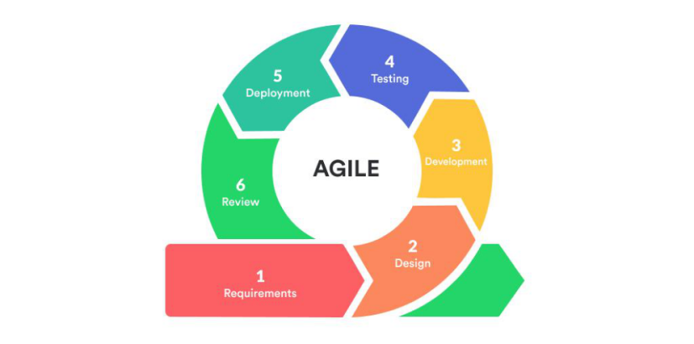

Figure 2. Agile Development Cycle
As shown in Figure 2, the Agile Development Cycle guided the entire process through iterative phases of Requirements, Design, Development, Testing, Deployment, and Review.

Requirement
The researchers will gather data through interviews, observation, and document analysis from the owner and staff of A and K Motorcycle Parts and Accessories. The objective will be to understand how sales and inventory are currently managed across the four branches, including how transactions are recorded, how stock levels are monitored, and how reports are prepared. The study will also examine the existing workflow in handling sales and tracking inventory to identify inefficiencies and challenges in the current system.
The findings are expected to reveal that sales and inventory are manually recorded, stock monitoring is inconsistent across branches, report preparation is time-consuming, and errors frequently occur in tracking inventory. These issues may result in inaccurate data, delays in decision-making, and difficulty in maintaining proper stock levels.
Based on these findings, the researchers will establish that a centralized web-based system will significantly improve business operations. The proposed system will be designed to centralize sales and inventory data from all branches, automate sales and inventory processes, provide real-time stock updates across branches, and generate accurate and timely reports, thereby enhancing efficiency, accuracy, and overall management of the business.

Design
The system design will be developed based on the findings gathered during the requirement phase. To illustrate how the Sales and Inventory Management System will function, the researchers will use system analysis models to create various design diagrams such as the Use Case Diagram, Entity Relationship Diagram (ERD), and Data Flow Diagram (DFD). These diagrams will demonstrate the interactions between administrators and staff, as well as the flow of data within the system. The interface will be designed to be simple and user-friendly to ensure that staff across all four branches can easily operate the system without requiring advanced technical skills.
The Use Case Diagram will illustrate how users interact with the system. It will show that administrators and staff will be able to log in, manage product records, process sales transactions, monitor inventory levels, and generate reports. These use cases will represent the primary responsibilities of users in handling daily operations within the system.
The Entity Relationship Diagram (ERD) will define the structure of the database. It will include key tables such as products, sales transactions, inventory records, and users. These tables will be interconnected to ensure accurate data storage and efficient retrieval of information. The design will ensure that all sales and inventory data from the four branches are centralized and properly organized within the system.
The Data Flow Diagram (DFD) will illustrate how data moves within the system. It will show how sales transactions entered by staff will automatically update inventory levels, and how data from all branches will be stored in a centralized database. The system will process this data to generate reports and provide real-time stock updates. This will ensure that all branches have access to accurate and up-to-date information.
The system will include key modules such as product management, inventory management, sales processing (Point of Sale), and reports and analytics. These modules will work together to improve data management, ensure accuracy, and streamline operations across all four branches. Overall, the design of the system will focus on efficiency, reliability, and ease of use, ensuring that it effectively supports the sales and inventory needs of the business.
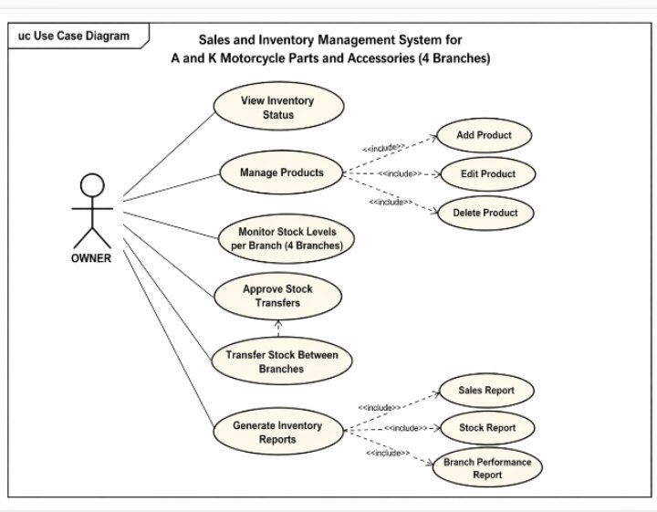
Figure 3. Use Case Diagram of Owner
The Use Case Diagram in Figure 3 illustrates how the Owner interacts with the Inventory Management System of A and K Motorcycle Parts and Accessories. These include viewing the overall inventory status, managing product information by adding, editing, and deleting products, and monitoring stock levels across the four branches. The owner can also approve stock transfers between branches to ensure proper distribution of items and generate inventory reports for monitoring and decision-making purposes.
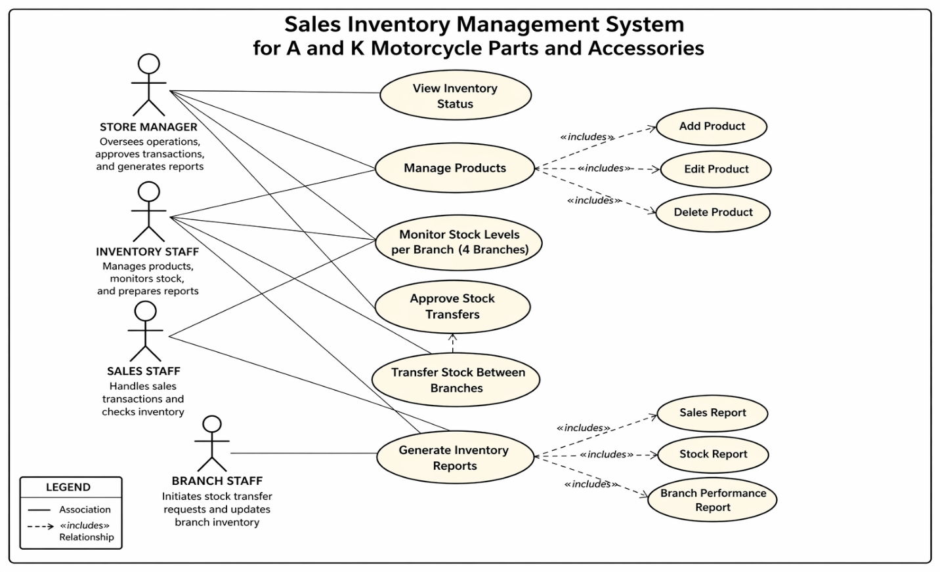
Figure 4. Entity Relationship Diagram
The Entity Relationship Diagram in Figure 4 illustrates the structure of the Sales and Inventory Management System for A and K Motorcycle Parts and Accessories across its four branches. The system consists of entities such as Branch, Product, Inventory, Staff, and Stock Transfer. Each branch maintains its own inventory records, where products are stored and monitored based on stock levels. The staff entity is associated with a specific branch and is responsible for managing inventory transactions. The stock transfer entity represents the movement of products between branches to ensure balanced distribution of items. These relationships enable the system to efficiently track and manage inventory across all branches.
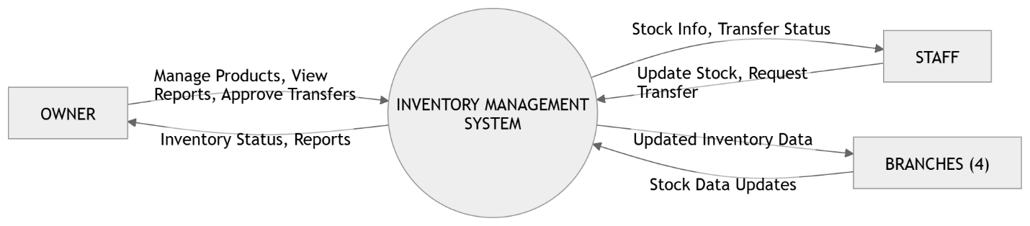
Figure 5. Data Flow Diagram (Level 0)
The Data Flow Diagram in Figure 5 illustrates how the users interact with the Inventory Management System of A and K Motorcycle Parts and Accessories. The system involves the owner, staff, and the four branches as external entities. The owner manages products, views inventory reports, and approves stock transfers, while the staff updates stock levels and requests transfers between branches. The branches provide stock data to the system, which processes and returns updated inventory information. This ensures accurate and real-time monitoring of inventory across all branches.

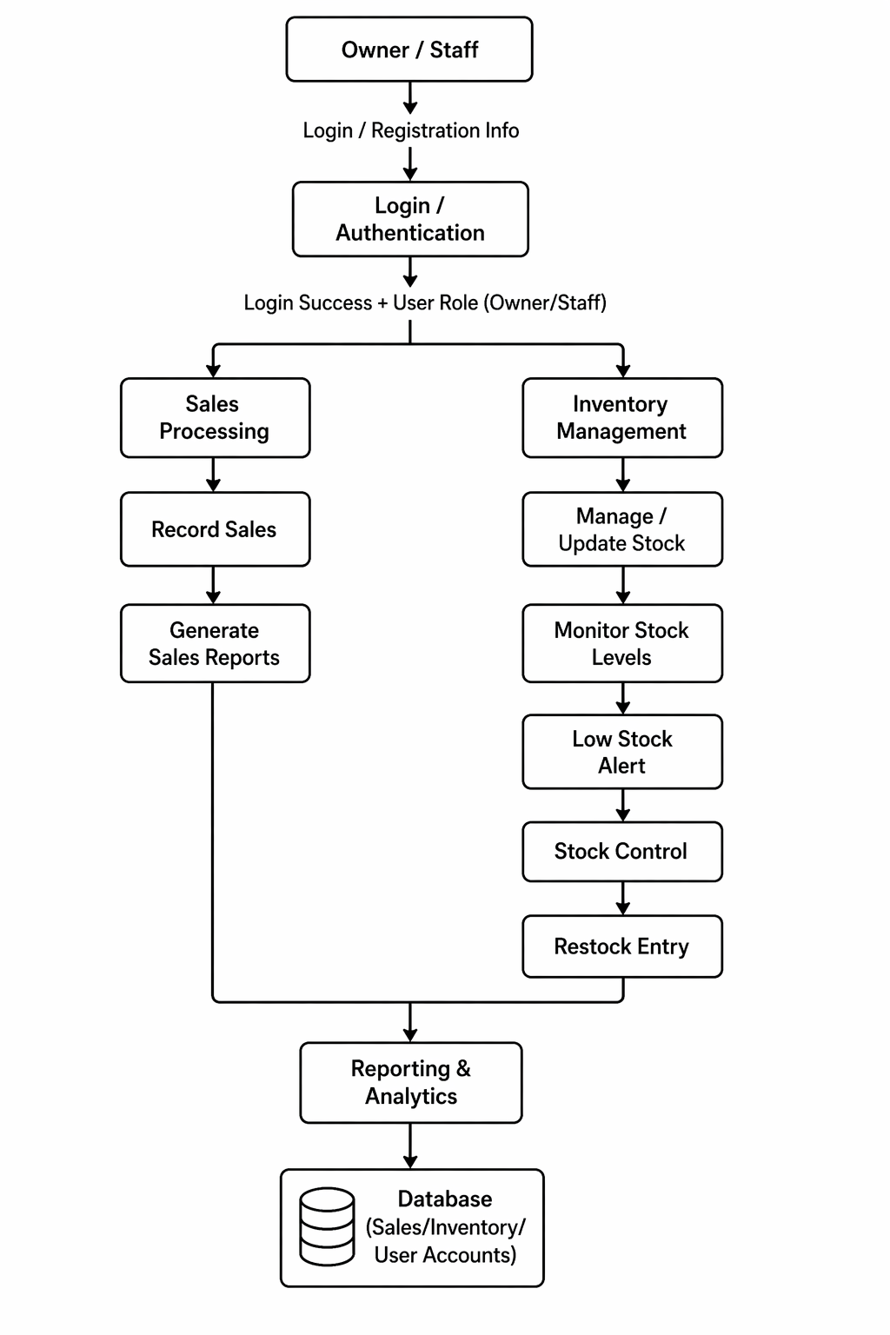
Figure 6. Data Flow Diagram (Level 1)
The diagram illustrates how the administrator (owner) and branch staff interact with the Sales and Inventory Management System of A and K Motorcycle Parts and Accessories across its four branches.
The process begins with the Owner/Staff, who enter their login or registration details into the system. Through the Login/Authentication stage, the system verifies user credentials and identifies their role (either owner or staff). Once access is granted, users are directed to the system’s main functional areas.
On one side, users handle Sales Processing. In this flow, staff record daily transactions through the Record Sales step. These transactions are then used to Generate Sales Reports, which provide insights into sales performance. This corresponds to the Process Sales Transaction (P2), where all sales data is captured and stored, ensuring that each transaction is properly documented and contributes to overall reporting.
On the other hand, users manage Inventory Management. This includes Manage/Update Stock, where product quantities are adjusted, followed by Monitor Stock Levels to track availability. When inventory reaches a critical level, the system triggers a Low Stock Alert, prompting action through Stock Control and Restock Entry. This reflects the Manage Inventory process (P3), ensuring that stock records remain accurate and up to date across all branches.
Both sales and inventory activities feed into the Reporting & Analytics component. This stage consolidates data from all branches, allowing both the administrator and staff to generate and access comprehensive reports (P4). These reports may include overall business performance, branch-specific data, and inventory status.
Finally, all information—sales transactions, inventory updates, and user data—is stored in a centralized Database. This database integrates the Product Database (D1), Sales Database (D2), and Inventory Database (D3), ensuring consistency and real-time synchronization across the system.
Overall, the diagram shows a streamlined flow where user authentication leads to either sales or inventory processes, both of which contribute to centralized reporting and data storage. This setup enables accurate record-keeping, real-time inventory monitoring, and informed decision-making for the business.

Barcode Scanning Sales & Inventory Flow
Customer selects product
↓
Cashier identifies product (brand/type)
↓
Search Barcode Catalog
↓
Scan barcode from catalog
↓
System retrieves product details
↓
Process sale transaction
↓
Automatic inventory deduction
↓
Update centralized database
↓
Generate receipt and reports

The diagram presents an alternative barcode scanning approach designed for efficiency and practicality in retail environments where attaching barcodes to each individual product is not feasible.
In this system, barcodes are not placed on every item. Instead, each product type or category is assigned a unique barcode, which is compiled in a Barcode Catalog organized by brand, category, or product type.
During a transaction, the cashier identifies the product and locates it in the Barcode Catalog. The corresponding barcode is then scanned directly from the catalog instead of the physical product. Once scanned, the system retrieves the product information and processes the sale.
After the transaction, the system automatically deducts the sold quantity from the inventory, ensuring real-time stock updates. All data is stored in a centralized database, allowing accurate monitoring across all branches.

Development
The system will be developed using web technologies such as HTML, CSS, JavaScript, and PHP or Node.js, with a MySQL database. It will be deployed as a web-based application and will be accessible through desktop and mobile browsers, allowing real-time synchronization of inventory data across all four branches. This setup ensures that all updates in the inventory system are reflected immediately across the branches, improving accuracy, efficiency, and consistency in managing stock information.

Testing
The Sales and Inventory Management System for A and K Motorcycle Parts and Accessories will be developed using web technologies such as HTML, CSS, JavaScript, and PHP or Node.js, with MySQL as the database. To ensure the system’s quality and reliability, it will undergo several testing methods, including unit testing, integration testing, system testing, and user acceptance testing (UAT).

Unit testing will be performed to verify that individual components—such as product listing, sales transactions, and inventory updates—function correctly. Integration testing will ensure that all modules work cohesively, especially in handling data synchronization across the four branches of the business. System testing will evaluate the overall performance, functionality, and stability of the complete system. Finally, user acceptance testing (UAT) will be conducted with actual users to confirm that the system meets business requirements and is easy to use.
The system will be evaluated based on the ISO/IEC 25010 Software Quality Model, focusing on key characteristics such as functionality, usability, efficiency, reliability, security, maintainability, compatibility, and portability. This evaluation will determine whether the system effectively supports sales and inventory management processes while maintaining data accuracy and system performance. The results are expected to demonstrate that the system is efficient, user-friendly, and reliable for managing operations across multiple branches, while also identifying areas for future improvement.

Deployment
The system will be deployed in A and K Motorcycle Parts and Accessories across its four branches.
It will be hosted on a centralized server or cloud-based system, allowing all branches to access and update sales and inventory data in real time. Staff will be trained to use the system for daily operations.

Review

In this phase, the researchers will conduct continuous monitoring and evaluation of the Sales and Inventory Management System for A and K Motorcycle Parts and Accessories after deployment. The primary objective is to ensure that all modules and system functions operate efficiently across the four branches and continue to meet the defined business requirements. Errors and issues identified during actual operation will be addressed through debugging and system updates using appropriate development tools, ensuring the system’s accuracy, stability, and overall performance.

System Evaluation
The Sales and Inventory Management System for A and K Motorcycle Parts and Accessories has been evaluated using the ISO/IEC 25010 Software Quality Model, which defines a set of quality characteristics essential for assessing and ensuring the overall quality of a software system. This model helps evaluate various attributes of the system to ensure it meets the following standards:
Functionality refers to the system’s ability to provide complete and accurate features for managing sales transactions, inventory tracking, and report generation across the four branches. The system ensures that all required functions operate correctly and deliver expected results efficiently.
Reliability is the system’s capability to maintain consistent performance under normal operating conditions. The system is designed to minimize errors and ensure continuous operation, especially in handling real-time data updates between branches.
Usability refers to the ease of use of the system and the effort required by users to operate it. The interface, developed using HTML, CSS, and JavaScript, is designed to be user-friendly, allowing staff to quickly learn and efficiently use the system.
Efficiency measures the system’s performance in relation to the resources used. The system is capable of processing transactions and updating inventory in real time while maintaining optimal speed and minimizing delays.
Maintainability refers to the ease with which the system can be modified, updated, or repaired. The use of structured development practices and technologies such as PHP or Node.js with MySQL allows developers to easily implement improvements and fix issues when necessary.
Portability is the ability of the system to be transferred and used in different environments. Being a web-based system, it can be accessed across various devices and platforms with minimal configuration.
Compatibility refers to the system’s ability to operate effectively with other systems and technologies. The system is designed to function across different web browsers and devices, ensuring smooth operation in diverse working environments.
Security is the system’s ability to protect data and restrict access to authorized users only. The system includes authentication mechanisms and data protection measures to safeguard sensitive sales and inventory information.

The Respondents
The study will engage a target group of participants to ensure both operational efficiency and technical integrity. The primary respondents include the store owner or manager, who provides the necessary administrative oversight, and the operational staff from all four branches, who offer practical insights into daily transactions and stock management. To validate the system’s performance and security, the study will also involve five IT experts specializing in software development and database management. These experts will evaluate the system’s technical architecture and functionality, ensuring that the final output is not only practical for the shop's daily operations but also meets professional industry standards for software reliability.
Research Gathering Instrument
The data was gathered using a valid and reliable researcher-made survey questionnaire. The system was evaluated using a 5-point Likert Scale, such as: 5 Excellent, 4-Very Good, 3-Good, 2-Fair, 1-Poor. Descriptive statistics was used to determine the level of assessment.

Scale Interpretation
4.20-5.00 Excellent
3.40-4.19 Very Good
2.60-3.39 Good
1.80-2.59 Fair
1.00-1.79 Poor

References
https://www.mdpi.com/2071-1050/13/5/2460, https://dl.ucsc.cmb.ac.lk/jspui/handle/123456789/3985. https://www.sourcecodester.com/php/14382/computer-parts-sales-and-inventory-system-using-phpmysql.html#google_vignette.

